**2019-2020 Kenai Beach Bacteria Monitoring Report**

FY20-21 Final Report

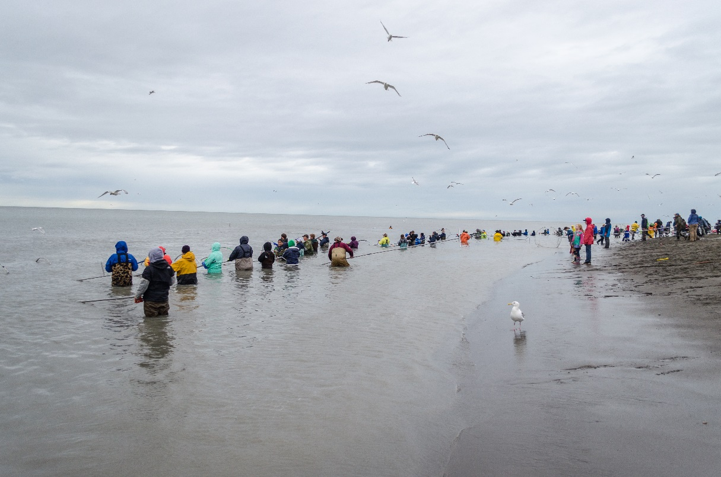

Prepared for the Alaska Department of Environmental Conservation

Grant: ACWA-19-B11

***The Kenai Watershed Forum is dedicated to successfully identifying and addressing the needs of the region by providing high quality education, restoration, and research programs.***



***“Working together for healthy watersheds on the Kenai Peninsula”***

**Draft report: 2021**

**Prepared by:**

Benjamin Meyer

Environmental Scientist

44129 Sterling Highway

Soldotna, Alaska 99669

(907) 260-5449

www.kenaiwatershed.org

Table of Contents

**List of Tables** ii

**List of Figures** iii

**Executive summary** 1

**Introduction** 2

**Methods** 3

**Monitoring locations** 4

**Sampling design** 6

2019-2020: Microbial source tracking 6

**Quality assurance and quality control** 7

**Water quality standards** 7

**Public outreach** 10

**Results** 10

**2019 Kenai beach bacteria monitoring** 10

2019 Microbial source tracking 15

**2020 Kenai beach bacteria monitoring** 15

2020 Microbial source tracking 19

**Discussion** 20

**2019-2020 Kenai beach bacteria monitoring** 20

2019-2020 Microbial source tracking 21

**Conclusions and recommendations** 23

**References** 25

**Appendix A: EPA Marine Beach Sanitary Survey** 26

**Appendix B: Chain-of-Custody** 27

**Appendix C: Press Releases** 28

**Appendix D: Site Photographs** 32

# **List of Tables**

Table 1. 2019-2020 Kenai beach bacteria monitoring site locations and descriptions. 4

Table 2. 2019-2020 Alaska Department of Environment Conservation water quality standards for fecal coliform and enterococci in marine waters. 9

Table 3. 2019 Kenai beach monitoring data for enterococci and fecal coliform. Individual exceedances used to determine public notice issuance are color coded by exceedance type. Public notices were retracted following two consecutive weeks of exceedances. 12

Table 4. 2019 rolling 30-day geometric means and comparison of results to statistical threshold value for enterococci at Kenai beach monitoring locations. Exceedances are color-coded by exceedance type. 13

Table 5. 2019 rolling 30-day geometric means and total sample exceedance percentages for fecal coliform results at Kenai beach monitoring locations. Exceedances are color-coded by exceedance type. 14

Table 6. 2019 microbial source tracking results from June and August sampling events on the Kenai River and its beaches. 15

Table 7. 2020 Kenai beach monitoring data for enterococci and fecal coliform. Individual exceedances used to determine public notice issuance are color coded by exceedance type. Public notices were retracted following two consecutive weeks of exceedances. 16

Table 8. 2020 rolling 30-day geometric means and comparison of results to statistical threshold value for enterococci at Kenai beach monitoring locations. Exceedances are color-coded by exceedance type. 17

Table 9. 2020 rolling 30-day geometric means and total sample exceedance percentages for fecal coliform results at Kenai beach monitoring locations. Exceedances are color-coded by exceedance type. 18

Table 10. 2020 microbial source tracking results from June and July sampling events on the Kenai River and its beaches. 19

Table 11. 2017-2020 late-run sockeye salmon counts on the Kenai River. Data sourced from Alaska Department of Fish and Game website in 2020. 22

# **List of Figures**

Figure 1. Kenai River and Kenai Beach dipnet PUF access locations (Alaska Department of Fish and Game, 2018). 2

Figure 2. 2018-2019 Kenai River beach sampling sites used for fecal coliform and enterococci monitoring. 5

# 

# **Executive summary**

Under contracts with the City of Kenai (CoK), the Kenai Watershed Forum (KWF) has been working with the Alaska Department of Environmental Conservation (ADEC) for several summers in an ongoing initiative to monitor bacteria concentrations at public beaches and within the lower six miles of the Kenai River in Kenai, Alaska. Bacteria monitored included fecal coliform and enterococci, both of which are found in the excrement of warm-blooded animals such as gulls. Gulls are attracted to Kenai beaches by fish carcasses produced during the personal use dipnet fishery (PUF). In order to establish a baseline for bacteria, Kenai Watershed Forum began monitoring fecal coliform and enterococci concentrations from 2010-2014 at sites in the lower six miles of the Kenai River and along its beaches at the mouth. In 2015, best management practices (BMPs) were implemented by the City of Kenai, which included clearing fish carcasses from the beaches at night during the dipnet personal use fishery to reduce the number of gulls present during the day. To assess changes in bacteria concentrations post-BMP implementation, Kenai Watershed Forum conducted monitoring from 2018-2020 at sites located at the North and South Kenai Beaches; Warren Ames Memorial Bridge; and upstream and downstream of the gull rookery. Microbial source tracking (MST) was also conducted prior to and during the personal use dipnet fishery in order to identify sources of these bacteria from 2019-2020. This document summarizes results throughout the 2019-2020 monitoring seasons and makes recommendations for the continuation of successful beach monitoring efforts in conjunction with the use of the Environmental Protection Agency (EPA) Virtual Beach Model.

# **Introduction**

The Kenai River is a glacially-fed river located on Alaska’s Kenai Peninsula that begins at the outlet of Kenai Lake and flows into Cook Inlet, a branch of the Gulf of Alaska. Known internationally for its prolific fisheries, the Kenai River supports the Cook Inlet’s largest population of wild Pacific Salmon. Each summer, thousands of recreationists participate in the Kenai River sportfishing season, which includes an Alaska resident-only personal use dipnet fishery (PUF) during much of July.

Since 1996, the Alaska Department of Fish and Game (ADFG) has managed the dipnet personal use fishery for Alaska residents under the Kenai River Late-Run Sockeye Salmon Management Plan (5 AAC 21.350, 2020). The dipnet personal use fishery is generally open from July 10th to July 31st starting from the Warren Ames Memorial Bridge between mile five and six of the Kenai River, to the mouth of the river, where the boundary extends along the North and South Kenai Beaches (Figure 1). While providing ample fishing and recreational opportunities for state resident recreationists, the dipnet personal use fishery also bolsters the local economy and is highly valued by many throughout the state. However, the fishery annually results in accumulation of fish carcass waste along the North and South Kenai beaches from fish cleaned on site by users.

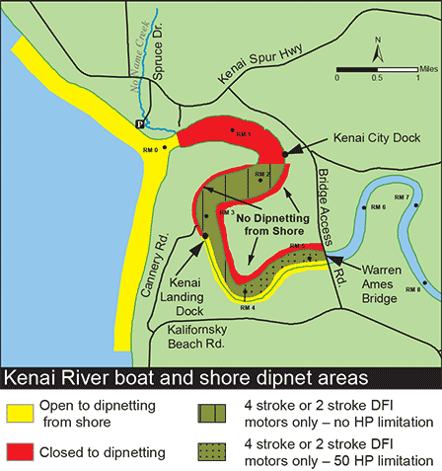

Figure 1. Kenai River and Kenai Beach dipnet PUF access locations (Alaska Department of Fish and Game, 2018).

Common practice of recreationists within the dipnet personal use fishery involves processing fish and discarding the waste along the beaches or within nearshore ocean water. It is also common to store freshly-caught fish on the beaches before processing them. The fish and resulting waste exposed along the beaches draws thousands of gulls from an established upstream gull rookery to the area each day to feed. The excrement from these gulls carries bacteria including fecal coliform bacteria and enterococci, which affect water quality along the North and South Kenai Beaches. When in exceedance of Alaska Department of Environmental Conservation water quality standards, these bacteria can be indicative of water containing concentrations of other bacteria that could induce illness.

Monitoring for fecal coliform and enterococci bacteria was initiated in 2010 in Kenai, Alaska. Throughout the 2010-2014 monitoring seasons, bacteria concentrations were found to periodically exceed the state standards throughout this timeframe and, in response, the City of Kenai implemented best management practices (BMPs) in 2014. These required the nightly clearing of fish carcasses from North and South Kenai Beaches and installing portable toilets during the personal use dipnet fishery season. Such practices were executed with the goal of reducing sources of bacteria, thereby minimizing the exposure of recreationists and fishermen.

Following three years of BMP implementation, Kenai Watershed Forum was contracted through the City of Kenai to work with ADEC to sample for fecal coliform bacteria and enterococci concentrations throughout the summers of 2018-2020. The sampling objective was to monitor changes in these bacteria concentrations post-BMP implementation. Kenai Watershed Forum conducted weekly bacteria sampling from May-September 2019 and 2020 at the North and South Kenai Beaches, two sites near the upriver gull rookery, and near the Warren Ames Memorial Bridge (Figure 2).

In order to examine the degree to which various potential sources of terrestrial feces (gull, human, and dog), sampling for microbial source tracking (MST) (Green et al., 2019) analyses was also conducted in 2019 and 2020 before and during the personal use dipnet fishery in order to identify and quantify fecal sources in the system.

Throughout the 2019-2020 monitoring period, several water quality exceedances of both fecal coliform and enterococci were identified, particularly at the North and South Kenai Beach sampling locations. In response, Kenai Watershed Forum collaborated with the City of Kenai and Alaska Department of Environmental Conservation to conduct public outreach and education centered around the potential health risks and preventative measures the public could take in order to avoid contact with contaminated water.

# **Methods**

Prior to monitoring each sampling season, the ADEC BEACH Water Quality Monitoring and Pathogen Detection Quality Assurance Project Plan (QAPP) was revised for sampling at five predetermined sites within the lower reaches of the Kenai River as well as along the North and South Kenai Beaches. Kenai Watershed Forum personnel were trained in sampling techniques using the methods outlined in the QAPP and sampling was supervised by senior personnel throughout the summer for consistency and technique. ADEC also joined for one sampling event each season for quality assurance.

## **Monitoring locations**

All five monitoring locations (Table 1 and Figure 2) are located throughout the lower six miles of the Kenai River and along the North and South Kenai Beaches at the Kenai River outlet along Cook Inlet. During peak recreation and fishing periods in July and August, this area experiences high pressure from both commercial and personal-use power boats as well as bank fisherman during the dipnet personal use fishery from July 10th -July 31st. The most upstream site, Warren Ames Memorial Bridge, receives little pressure from fishermen and was chosen as a monitoring site for background concentrations of fecal coliform and enterococci bacteria. Further downstream near the Kenai River outlet is a large gull rookery located on river left that, at times, plays host to thousands of gulls. The North and South Kenai Beaches located near the Kenai River outlet draw thousands of dipnetters during the personal use fishery season. Sampling site photographs can be found in Appendix D.

Table 1. 2019-2020 Kenai beach bacteria monitoring site locations and descriptions.



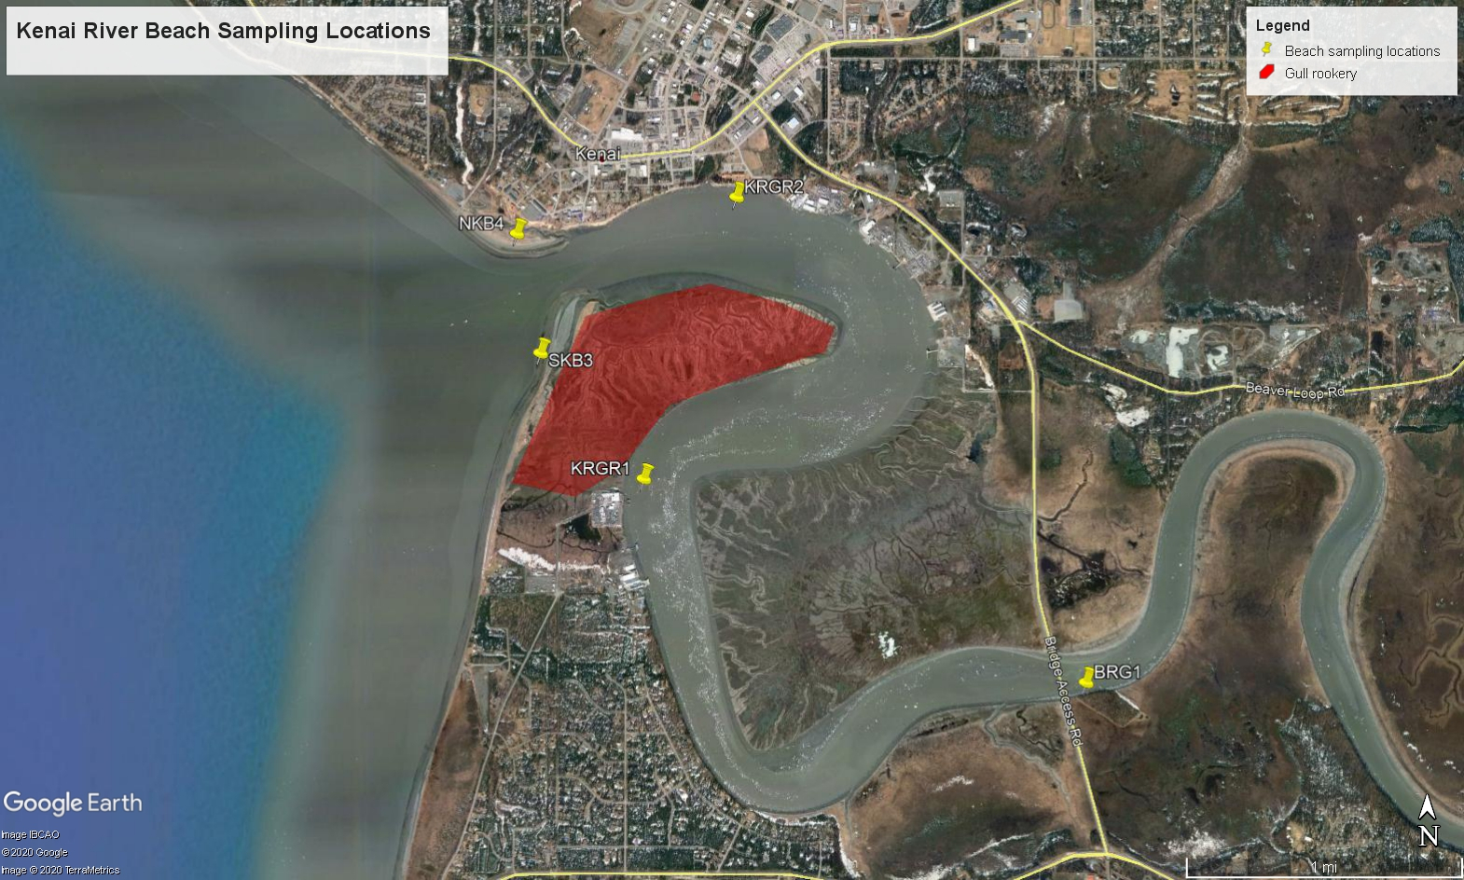

Figure 2. 2019-2020 Kenai River beach sampling sites used for monitoring fecal coliform, enterococci, and microbial source tracking.

## **Sampling design**

Sites selected for monitoring throughout the 2019 and 2020 sampling seasons remained consistent with those used in previous years. These included a sampling site at the Warren Ames Memorial Bridge (BRG1), above and below the gull rookery in the Kenai River (KRGR1 and KRGR2, respectively), and two different areas on both the North (NKB4) and South (SKB3) Kenai Beaches (Figure 2).

During a typical sampling event, morning site visits were conducted within a few hours of high tide. Sites near the gull rookery were accessed by boat while all other sites were accessed by foot. At each site, two 100-mL grab samples of water were collected from the river: one for fecal coliform bacteria and one for enterococci. A set of replicate samples was collected for quality control during each sampling event, rotating between the North and South Kenai Beach sampling sites. In-situ air and water temperatures were collected using a YSI 650 MDS or YSI Pro 20 multiprobe meter; local observations were made regarding the weather, tides, beach, activity noted on the beach, and potential sources of contamination (gulls, boats, etc). Wave height and turbidity were also assessed in 2020 at the Warren Ames Memorial Bridge and both North and South Kenai Beaches using a yard stick and Hach 2100Q Portable Turbidimeter, respectively. For the purpose of quantifying and referencing observed fishermen, campers, and other beach-goers, the all-encompassing term “recreationists” will be used throughout this report. All field observations were recorded on an EPA Marine Beach Sanitary Survey found in Appendix A.

All grab samples were packaged and shipped on ice with a chain-of-custody form (see Appendix B) within six hours of sampling via commercial air carrier to ADEC-certified laboratory, SGS North America Inc, for analyses in Anchorage. As required by the project QAPP, the quantity of fecal coliform bacteria per 100-mL sample was determined using analytical method ID SM-9222D while the quantity of enterococci per 100-mL sample was determined using analytical method ID D6503-99 (Alaska Department of Environmental Conservation: Division of Water, 2012). Results of these analyses were reported by the laboratory to Kenai Watershed Forum and ADEC within 48 hours of receiving the samples. If exceedances were present, employees of Kenai Watershed Forum, Alaska Department of Environmental Conservation, and City of Kenai collaboratively acted to alert the public of the risks of exposure and preventative measures to take in order to avoid contact with the contaminated water body. ADEC also produced press releases (Appendix C).

### 2019-2020: Microbial source tracking

Sampling was conducted at all five Kenai River bacteria monitoring locations in 2019 and 2020 for microbial source tracking (MST), a method used to identify sources of fecal contamination based on genetic markers. MST methodology was employed to test for the presence of dog, human, and gull fecal matter- all potential sources contributing to bacteria concentrations in the Kenai River system. In 2019, the first sampling event occurred prior to start of the personal use dipnet fishery on June 4th and a second event occurred on July 23rd. Concentrations of bacteria were not sufficiently elevated for MST analysis in samples from the second sampling event of 2019, thus these samples were not analyzed and ADEC requested a third sampling event, held on August 1st, 2019. In 2020, MST sampling events took place on June 23rd and July 20th.

All sampling events for MST corresponded with a standard bacteria sampling event. Prior to each sampling event, five 500-mL sterile sampling bottles were packaged individually wrapped in paper towels and stored in ziplock bags. Once in the field, personnel cleaned hands and wore new disposable gloves. Sample bottles remained closed until immediately prior to sample collection. Each bottle was labeled with sampling location, sample type (MST), date, and time. One grab sample was taken per monitoring location and subsequently packaged and shipped on ice with a corresponding chain-of-custody form (Appendix B) within six hours of sampling via commercial air carrier to the ADEC-certified laboratory, SGS North America Inc (SGS), in Anchorage. To concentrate bacteria within the samples, SGS processed all samples via a sterile, vacuum filtration method. All resulting filters were stored in a freezer until notified by Kenai Watershed Forum to overnight mail the frozen samples with a temperature blank to ADEC-approved Source Molecular in Miami, Florida, where the bacteria source was identified by genetic markers using quantitative polymerase chain reaction (qPCR) and Digital PCR technologies.

## **Quality assurance and quality control**

Data was reviewed for quality control and assurance by the ADEC Project Manager assigned to this monitoring program as well as the Grantee Project Quality Assurance Officer. In addition, a duplicate, quality control sample was taken for both fecal coliform and enterococci analyses. These samples alternated between the North and South Kenai Beaches each week. The higher of the two results for both fecal coliform and enterococci was utilized during data analysis. All data was uploaded to the state Ambient Water Quality Monitoring System (AQWMS) by ADEC.

## **Water quality standards**

Fecal coliform and enterococci analyses results from the 2019 and 2020 monitoring seasons were evaluated based on the Alaska water quality standards for marine water (18 AAC 70 (14)). Fecal coliform exceedances were determined based on standards set for secondary water recreation and harvesting raw aquatic life for consumption (Table 2).

Criteria for these standards require the results of a minimum of 5 samples to calculate a 30-day rolling geometric mean. In instances where a 30-day period included a bacterium result of 0 CFU (colony forming units) per 100 mL, this result was not included in the geometric mean calculation.

Exceedances were also identified when > 10% of samples in the prior 30 days exceeded a specified threshold.

Table 2. 2019-2020 Alaska Department of Environment Conservation water quality standards for fecal coliform and enterococci in marine waters.

|  |  |  |
| --- | --- | --- |
| **Water Quality Standards for Bacteria: Marine Water Uses** | | |
|  | **Fecal coliform** | **Enterococci** |
| **Water recreation:** contact recreation, 18 AAC 70 (14)(B)(i) |  | In a 30-day period, the geometric mean of samples may not exceed 35 enterococci CFU/100 ml, and* not more than 10% of the samples may exceed a statistical threshold value (STV) of **130 enterococci CFU/100 ml.** |
| **Water recreation:** secondary recreation, 18 AAC 70 (14)(B)(ii) | In a 30-day period, the geometric mean of samples may not exceed 200 fecal coliform/100ml, and* not more than 10% of the samples may exceed **400 fecal coliform/100ml.** |  |
| **Harvesting for consumption of raw mollusks or other raw aquatic life,** 18 AAC 70 (14)(D) | The geometric mean of samples may not exceed 14 fecal coliform/100 ml; and* not more than 10% of the samples may exceed; |  |
| - 43 MPN per 100 ml for a five-tube decimal dilution test; |  |
| - 49 MPN per 100 ml for a three-tube decimal dilution test; |  |
| - 28 MPN per 100 ml for a twelve-tube single dilution test; |  |
| ***- 31 CFU per 100 ml for a membrane filtration test (see note 14)\*\*\**** |  |
| MPN = Most Probable Number. Unit equivalent to Colony Forming Unit (CFU). | | |
| *For single-year analysis, "and" is replaced with "or". | | |
| **Standard that was referenced based on analysis methodology used by the laboratory. | | |
| ***Note 14. When fecal coliform levels are monitored in waters designated as state approved shellfish harvesting and growing waters, these waters are also subject to 18 AAC 34.010(19). | | |
| **Bold** text indicates values used to determine exceedances for public notices. | | |
| Alaska Water Quality Standards for Marine Water (18 AAC 70 (14)) | | |

During the summer monitoring period, weekly exceedances were identified when results exceeded 130 enterococci CFU/100 mL for water recreation (contact recreation), 400 fecal coliform CFU/100 mL for water recreation (secondary recreation), and/or 31 fecal coliform CFU/100 mL for a membrane filtration test for harvesting for consumption of raw mollusks or other raw aquatic life (Table 2). When an exceedance occurred during the personal use dipnet fishery season a public advisory was issued. Advisories were active until two consecutive weeks of bacteria concentrations below exceedance criteria were achieved.

## **Public outreach**

Public outreach remained a critical component of effective bacteria monitoring during the 2019 and 2020 monitoring seasons. ADEC and the City of Kenai partnered with Stream Watch, a Kenai Watershed Forum and U.S. Forest Service program specializing in angler education and outreach, to disseminate information on ways to avoid contact with bacteria and proper fish handling at North Kenai Beach. Education was provided in the form of brochures and personal communication. Booth visitors verbally expressed their appreciation for handouts including fin clippers and dog bags, which aim to help reduce the fecal bacteria contributed by dogs along the beach. Volunteer participation metrics were recorded in 2020 and include staffing a booth for 59 hours during which volunteers conducted peer-to-peer education with 383 recreationists, as well as a total of 93 pounds of trash collected.

To further notify the public, ADEC issued educational radio ads that were played four times per week during the dipnet personal use fishery. In addition, Facebook advisory posts were made regarding generalized weekly exceedances of water quality criteria, as well as guidelines for minimizing contact with bacteria, which can be found at <https://dec.alaska.gov/water/water-quality/beach-program/kenai-river-beaches-dipnetting-safety/>. These posts can be found on the ADEC Facebook page: <https://www.facebook.com/AlaskaDEC/>. Two press releases were released in response to site-specific bacteria exceedances in 2019; these detailed precautionary measures the public should take to avoid bacteria-impacted marine water (Appendix C). Emails were sent to local partners each week during the sampling season, summarizing the results from sampling event that week. In 2020 the option to enlist in the email listserv was made available for partners interested in receiving results. ADEC also updated their website to include a beach advisory map in 2020; the map can be found here: <https://dec.alaska.gov/water/water-quality/beach-program/kenai-river/>.

# **Results**

## **Results summary**

Bacteria monitoring efforts in 2019-2020 revealed instances of criteria exceedance based on the Alaska Water Quality Standards for consumption of raw aquatic life at all five sites, for contact recreation at two sites (South Kenai Beach and North Kenai Beach), and for secondary recreation at one site (South Kenai Beach). Microbial Source Tracking using species-specific genetic markers revealed that gulls were overwhelmingly the source of most fecal matter all sites.

## **Bacteria concentrations monitoring**

The two beach sites at the mouth of the Kenai River exhibited regular exceedance of several criteria thresholds for both enterococci and fecal coliform throughout the 2019-2020 sampling seasons, while the upstream sites at the two gull rookeries and Warren Ames Bridge exhibited exceedances less severe in concentration and duration.

All five sites exhibited instances of exceedance of thresholds for consumption of raw aquatic life (fecal coliform 30-day geometric mean > 14 CFU/mL or 10% of samples from prior 30 days > 31 CFU/mL). In addition, the North and South Beach sites saw exceedances of criteria for contact recreation (enterococci 30-day geometric mean > 35 CFU/mL or 10% of samples from prior 30 days > 130 CFU/mL). The South Kenai Beach site saw the greatest magnitude and frequency of exceedances, with some instances of thresholds surpassed for secondary recreation (10% of fecal coliform samples from prior 30 days > 400 CFU/mL) (Figure X, Appendix X).

Share quick numeric survey of results

Geometric means values for enterococci at South Kenai Beach ranged from 10.10-131.52 CFU/100 mL, and those related to individual sample exceedances occurred five out of 8 times beginning July 2, 2019 (Table 4). The geometric means for enterococci at North Kenai Beach ranged from 7.86-67.03 CFU/100 mL throughout the 2019 monitoring season and those related to individual sample exceedances occurred sporadically beginning June 4, 2019 (Table 4).

In contrast to enterococci, exceedances based on fecal coliform standards (harvesting raw mollusks or other raw seafood for consumption) occurred at all five sampling sites in 2019. Fecal coliform sampling results from the South Kenai Beach resulted in a range in geometric means of 10.1-131.52 CFU/100 mL as well as a seasonal exceedance (Table 5). Geometric means at North Kenai Beach ranged from 7.86-67.03 CFU/100 mL; this beach also experienced a seasonal exceedance for fecal coliform (Table 5). Exceedances based on geometric means and seasonal data for fecal coliform results at the Warren Ames Memorial Bridge and the Kenai Gull Rookery sampling sites are summarized in Table 5.

In response, ADEC issued a press release on June 6, 2019 for the North Kenai Beach for water impacted by elevated concentrations of enterococci and fecal coliform. Later that month, a press release was issued on June 20, 2019, lifting the advisory for enterococci on the North Kenai Beach while implementing one for water impacted by elevated concentrations of fecal coliform at both North and South Kenai Beaches and the upstream Kenai Gull Rookery sampling site for consumption of raw seafood. The final press release was issued on July 5, 2019 for waters impacted by elevated concentrations of fecal coliform and enterococci at both North and South Kenai Beaches as well as both Kenai Gull Rookery sampling sites. These exceedances occurred for both contact water recreation and consumption of seafood. All press releases can be found in Appendix C and supporting results can be found in Table 3.

Exceedances related to geometric means for enterococci at South Kenai Beach ranged from 10.10-131.52 CFU/100 mL, and those related to individual sample exceedances occurred five out of 8 times beginning July 2, 2019 (Table 4). The geometric means for enterococci at North Kenai Beach ranged from 7.86-67.03 CFU/100 mL throughout the 2019 monitoring season and those related to individual sample exceedances occurred sporadically beginning June 4, 2019 (Table 4).

In contrast to enterococci, exceedances based on fecal coliform standards (harvesting raw mollusks or other raw seafood for consumption) occurred at all five sampling sites in 2019. Fecal coliform sampling results from the South Kenai Beach resulted in a range in geometric means of 10.1-131.52 CFU/100 mL as well as a seasonal exceedance (Table 5). Geometric means at North Kenai Beach ranged from 7.86-67.03 CFU/100 mL; this beach also experienced a seasonal exceedance for fecal coliform (Table 5). Exceedances based on geometric means and seasonal data for fecal coliform results at the Warren Ames Memorial Bridge and the Kenai Gull Rookery sampling sites are summarized in Table 5.

Table 3. 2019 Kenai beach monitoring data for enterococci and fecal coliform. Individual exceedances used to determine public notice issuance are color coded by exceedance type. Public notices were retracted following two consecutive weeks of exceedances. 

Table 4. 2019 rolling 30-day geometric means and comparison of results to statistical threshold value for enterococci at Kenai beach monitoring locations. Exceedances are color-coded by exceedance type.



Table 5. 2019 rolling 30-day geometric means and total sample exceedance percentages for fecal coliform results at Kenai beach monitoring locations. Exceedances are color-coded by exceedance type.



### 2019 Microbial source tracking

Sampling for microbial source tracking (MST) was conducted in June and August of the 2019 monitoring season. MST results from the June sampling event reported quantifiable gull fecal marker copies at all five sampling sites, ranging from 938-3610 marker copies/100 mL (Table 6). Marker copies for human feces were either not detected or detected but not quantifiable at any of the five sites at which samples were collected. Evidence of dog feces was noted at only North and South Kenai Beaches, whose quantified presence of markers were 4660 marker copies/100 mL and 1210 marker copies/100 mL, respective (Table 6).

During the August MST sampling event, the presence of dog feces was either not detected or not quantifiable at any of the five sites at which sampling was conducted. With the exception of the upstream Kenai Gull Rookery sampling site, human fecal matter was detected by not quantifiable at sampling locations. In contrast, gull feces were detected at all five sampling locations in August. Results varied from 2920-28200 marker copies/100 mL for gull feces (Table 6).

Table 6. 2019 microbial source tracking results from June and August sampling events on the Kenai River and its beaches.



## **2020 Kenai beach bacteria monitoring**

Table 7. 2020 Kenai beach monitoring data for enterococci and fecal coliform. Individual exceedances used to determine public notice issuance are color coded by exceedance type. Public notices were retracted following two consecutive weeks of exceedances.



Table 8. 2020 rolling 30-day geometric means and comparison of results to statistical threshold value for enterococci at Kenai beach monitoring locations. Exceedances are color-coded by exceedance type.



Table 9. 2020 rolling 30-day geometric means and total sample exceedance percentages for fecal coliform results at Kenai beach monitoring locations. Exceedances are color-coded by exceedance type.



### 2020 Microbial source tracking

Sampling for microbial source tracking (MST) was conducted prior to the dipnet PUF in June and once during the dipnet PUF in July 2020. MST results from the June sampling event reported the detection of gull fecal marker copies at all five sampling sites but not quantifiable at South Kenai Beach and Warren Ames Memorial Bridge. Quantifiable levels ranged from 688-3320 marker copies/100 mL (Table 10). Marker copies for human feces were not detected at any of the five sampling sites and copies for dog feces were only detected at the Warren Ames Memorial Bridge but were not quantifiable.

During the July MST sampling event, marker copies for gull feces were detected at quantifiable levels at all five sampling locations and ranged from 1590-13100 copies/100 mL (Table 10). Detectable levels of human feces were noted at all five sampling locations as well, though not quantifiable at the Warren Ames Memorial Bridge and the upstream gull rookery site; quantifiable results ranged from 629-1220 copies/100 mL (Table 10). Finally, dog feces were only detected at the North and South Kenai Beaches in July, but were not able to be quantified.

Table 10. 2020 microbial source tracking results from June and July sampling events on the Kenai River and its beaches.



# **Discussion**

## **2019-2020 Kenai beach bacteria monitoring**

Throughout the 2018 bacteria monitoring season, enterococci exceedances occurred consistently at the South Kenai Beach, while most exceedances at North Kenai Beach were detected in the latter half of the sampling season. The higher concentrations of enterococci at North Kenai Beach can likely be explained by the increase in fish carcasses and therefore gulls during the dipnet PUF in July. In addition, it has been hypothesized that patterns in outgoing river water and tidal currents result in a north-to-south movement at the mouth of the Kenai River. This would explain the consistency in exceedances at the South Kenai Beach for enterococci, though it is highly recommended that this is researched in greater depth. Similar patterns in exceedance timing for enterococci were also observed in 2019, though exceedances at South Kenai Beach began at the beginning of July.

Seasonal exceedances for fecal coliform occurred at all five sampling locations during both the 2018 and 2019 monitoring seasons. Notably, the percentage of samples exceeding the 10% provision (harvesting raw mollusks or other seafood for consumption) in 2018 exceeded the percentages in 2019. While the 2019 dipnet PUF report submitted by the City of Kenai did not address changes in attendance, it did state that overall revenue was down from 2018 (Ostrander, 2019). Assuming there is a correlation between attendance and revenue, lower attendance in 2019 may have led to fewer carcasses and gulls present at the beach, and therefore lower bacteria concentrations.

The expansion in the number of sampling weeks throughout the 2019 monitoring season was intended to provide further insight into bacteria concentrations before and after the dipnet PUF season.

It is important to note that, due to limited sampling events conducted on a weekly basis, geometric means could not be calculated until at least five samples were collected in a 30-day period. Therefore, geometric means could not be calculated until late-July in 2018 and mid-June in 2019. However, exceedances based on the 10% provision of water quality standards for bacteria in marine settings could be implemented for each sampling season. In response, the number of sampling weeks throughout the 2019 monitoring season was expanded with the intension of providing further insight into bacteria concentrations before and after the dipnet PUF season.

While the data collected during the 2018 and 2019 monitoring seasons was not sufficient to implement the Environmental Protection Agency's (EPA) Virtual Beach Model, they provided insight into bacteria concentrations before and after the dipnet PUF. Moving forward, it is recommended that sufficient data is collected in coming years in order to implement this model. In doing so, it can be determined if extended sampling similar to that conducted in 2019 should be continued or if fewer sampling events would be sufficient in order to "spot check" bacteria concentrations throughout the summer.

Emergency orders for sport fishing were issued by ADFG throughout the 2018 and 2019 monitoring seasons. Due to failure to meet the sustainable escapement goal for sockeye, an emergency closure was issued for the dipnet PUF on July 30, 2018, cutting the season back by two days. In contrast, ADFG extended the dipnet PUF hours to 24 hours/day through the 2019 dipnet PUF season closure on July 31, 2019. It remains unclear if these emergency orders directly or indirectly affected bacteria concentrations along the Kenai Beaches but the dipnet PUF experienced a 30% decrease in attendance throughout the 2018 season (Ostrander, 2018). An additional change made in 2019 was the reduction in the frequency that North and Sound Kenai Beaches were raked by the CoK; this decision was based on observations from previous years (Ostrander, 2019). As stated previously, overall revenue in 2019 was down from 2018, which may be an indication that attendance was down as well (Ostrander, 2019). Due to this potential decrease in attendance (and likely the number of carcasses on beaches), it cannot be determined if the reduction in raking had a direct effect on bacteria concentrations at North and South Kenai Beaches. As a result, it is recommended that ADEC work closely with CoK to effectively implement BMPs based on dipnet PUF attendance, carcass concentrations along beaches, etc... for each year. A modification of BMPs to include disposal or compost of carcasses could be a more permanent, effective way to mitigate the effects on bacteria concentrations.

Finally, a continuation in open communication with local stakeholders will remain a critical component of successful and meaningful bacteria monitoring. Emails to stakeholders summarizing weekly sampling results have shown to be effective for conveying data in a transparent manner. Public education and outreach events have also been proven effective, and should continue during future monitoring seasons. Public advisories have reached thousands of radio listeners, Facebook viewers, etc... That being said, it is highly recommended that protocol is developed to increase consistency in when advisories are issued and subsequently removed after two weeks of bacteria concentrations below exceedance threshold.

### 2019-2020 Microbial source tracking

While it is widely accepted that bacteria are derived from local gull populations and those that flock to the North and South Kenai Beaches, limited MST data has been gathered during previous Kenai bacteria monitoring events. Historically, sample analysis for MST was conducted in 2011 and 2014; results can be found here: <https://dec.alaska.gov/water/water-quality/beach-program/>.

MST samples analyzed from the 2019 sampling events in June and August reported gull feces at all five sampling sites. The highest concentration of marker copies associated with gull fecal matter were detected at both Kenai Gull Rookery sites in June, while the concentration of gull marker copies was an order of magnitude higher at North and South Kenai Beaches than all other sites during the August sampling event. This is very likely due to the increase in the number of carcasses (and therefore gulls) along the beaches.

In 2020, both Kenai gull rookery sampling sites displayed higher levels of full feces than any other site in June, likely due to their proximity to the rookery itself. However, quantifiable results for gull feces were reported at all five sites in July during the dipnet PUF during which marker copies were one order of magnitude higher at South Kenai Beach than any other sampling site. In conjunction with the increased numbers of salmon carcasses on the beach, the thought that output from the Kenai River flows south along the South Kenai Beach would explain this higher concentration of gull feces. However, further research into flow patters at the Kenai River outlet is required.

In comparison, concentration of gull marker copies was roughly twice as high at North and South Kenai Beaches in 2019 than in 2020. This could be explained by the somewhat delayed run timing of late-run sockeye in 2020, which draw thousands of gulls to both beaches when carcasses are strewn along the beaches by dipnet PUF participants (Table 11).

Finally, it is critical to note that the mouth of the Kenai is a dynamic and ever-changing zone. Influenced by fluctuating river discharge, tides, wind, and boat traffic, patterns in water flow can vary by the minute. Therefore, each MST result is a snapshot of conditions at that time and location-not necessarily a representation of the water in an area as a whole.

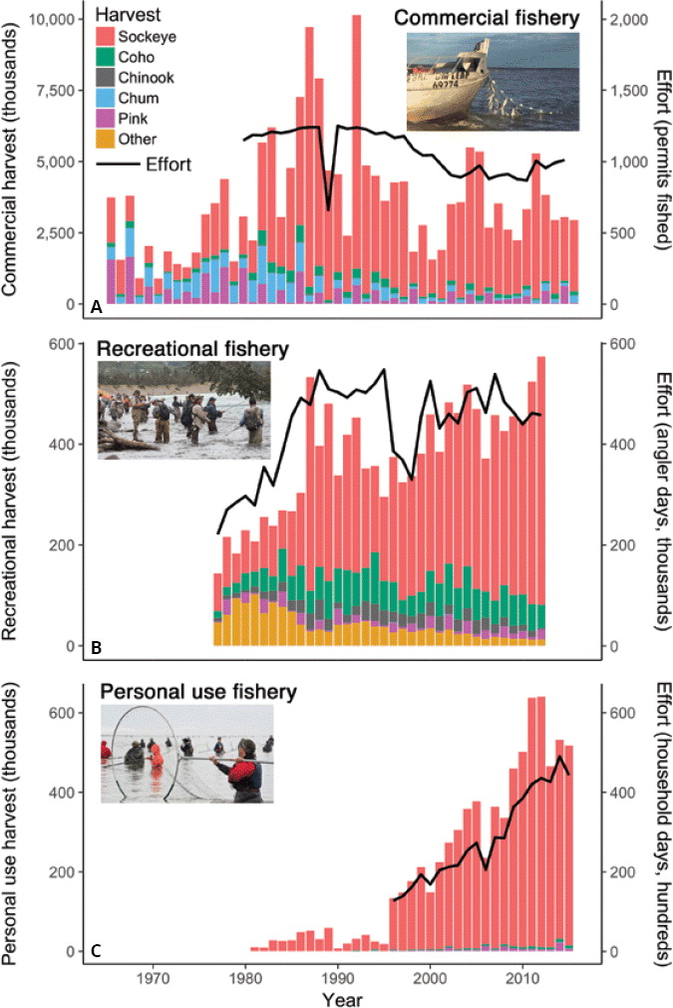

(insert caption link) Growth of the Kenai River personal use fishery in harvest (left axis) and effort (right axis). The fishery is almost exclusively for sockeye salmon (red color), though small numbers of other salmon species are also captured (other colors at bottom of chart). Figure adapted from Schoen et al. 2017.

Table 11. 2017-2020 late-run sockeye salmon counts on the Kenai River. Data sourced from Alaska Department of Fish and Game website in 2020.

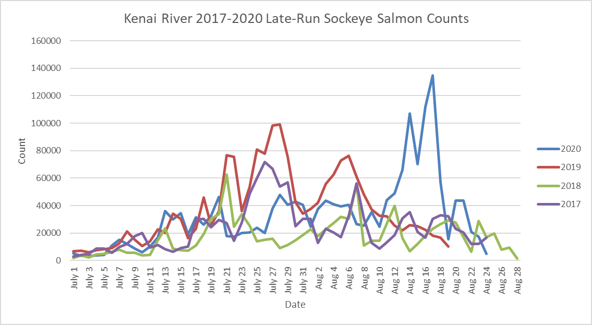

# **Conclusions and recommendations**

Data collected throughout 2018 and 2019 provided insight into some of the factors involved in the fluctuation of bacteria concentrations at the Kenai Beaches and the sources of these bacteria throughout the summer months. Moving forward, the following recommendations should be taken into consideration:

1. While North Kenai Beach continues to experience bacteria exceedances each year, South Kenai Beach is shown to have more frequent exceedances. Both beaches are impacted by an increase in carcasses and therefore gulls during the dipnet personal use fishery.
   1. Additional research surrounding patterns in tidal currents and river outflow at the mouth of the Kenai River is highly recommended, as these patterns may inform the discrepancy in bacteria concentrations between beaches.
   2. It is recommended that ADEC work with the City of Kenai to assess the effectiveness of current BMPs and modify if necessary. With a long term time series, the effectiveness of BMPs would likely be readily evident in the data, though trends should be considered in the context of the rapid growth of the personal use fishery in the past two decades. One modification of BMPs could include requiring the immediate disposal or composting of carcasses on the beach.
2. Consistent communication with stakeholders and user groups will remain critical to effective beach monitoring. Protocol should be established to ensure consistency in when public advisories are issued and for what sites they are necessary.
3. Because MST analyses provide results for single-sample events, the results from 2019-2020 provide a snapshot of bacteria marker copy concentrations at the time of sampling. Due to extremely dynamic patterns in current at the mouth of the Kenai, more consistent sampling for MST is recommended in order to assess spatiotemporal variation in bacteria sources.
4. Data collection for additional parameters including wave height is recommended in future years in order to effectively implement EPA's Virtual Beach Model. In the future, this modeling could inform the amount of sampling required to effectively issue public advisories for bacteria.
   1. Using the results of the Virtual Beach Model, it is advised that a monitoring program be established in perpetuity in order to issue public advisories when necessary.
   2. All data from previous years should be

These four actions would support educated management decisions, encourage preservation of environmental habitat, mitigate potential public health issues, and ensure transparency of the beach monitoring process.

# **Data availability**

All data and R programming scripts used in this analysis is available in a public repository at https://github.com/Kenai-Watershed-Forum/KWF_Beach_Sampling_2019_2020 .

# **References**

Alaska Department of Environmental Conservation (ADEC). (2018). *2018 Water Quality Standards*.

Alaska Department of Fish and Game. (2018). *Kenai River boat and shore dipnet areas* [Digital image]. Retrieved December 12, 2018, from www.adfg.alaska.gov/index.cfm?adfg=personalusebyareasouthcentralkenaisalmon.main.

Alaska Department of Environmental Conservation (ADEC). (2012). *Kenai BEACH Water Quality Monitoring and Pathogen Detection: Quality Assurance Project Plan, Rev. 3*.

Alaska Department of Environmental Conservation (ADEC). (2012). *Kenai BEACH Water Quality Monitoring and Pathogen Detection: Quality Assurance Project Plan, Rev. 4*.

5 AAC 21.360, Alaska Admin Code. (2020). *Kenai River Late Run Sockeye Salmon Management Plan*. <http://www.legis.state.ak.us/basis/aac.asp#5.21.360>.

Green, H., Welker, D., Johnson, S., Michalenko, E. (2019). *Microbial Source-Tracking Reveals Origins of Fecal Contamination in a Recovering Watershed*. Water **2019**, 11(10), 2162; <https://doi.org/10.3390/w11102162>.

Ostrander, P. (2019). *2019 Personal Use Fishery (Dip Net) Report*. Kenai, Alaska: City of Kenai.

Schoen et al. 2017

## **Appendix A: EPA Marine Beach Sanitary Survey**

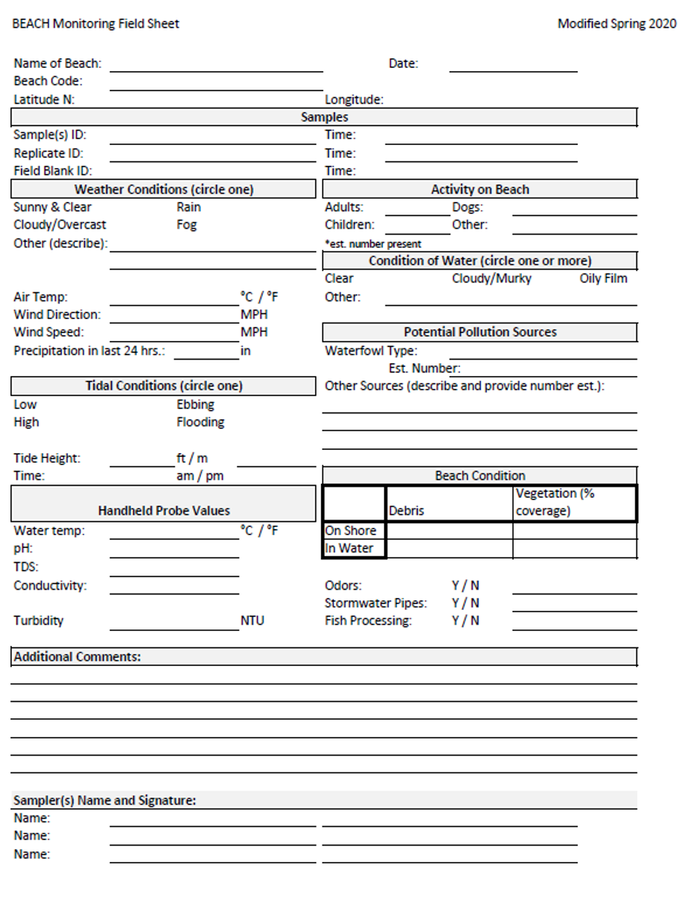

## **Appendix B: Chain-of-Custody**



## **Appendix C: Press Releases**

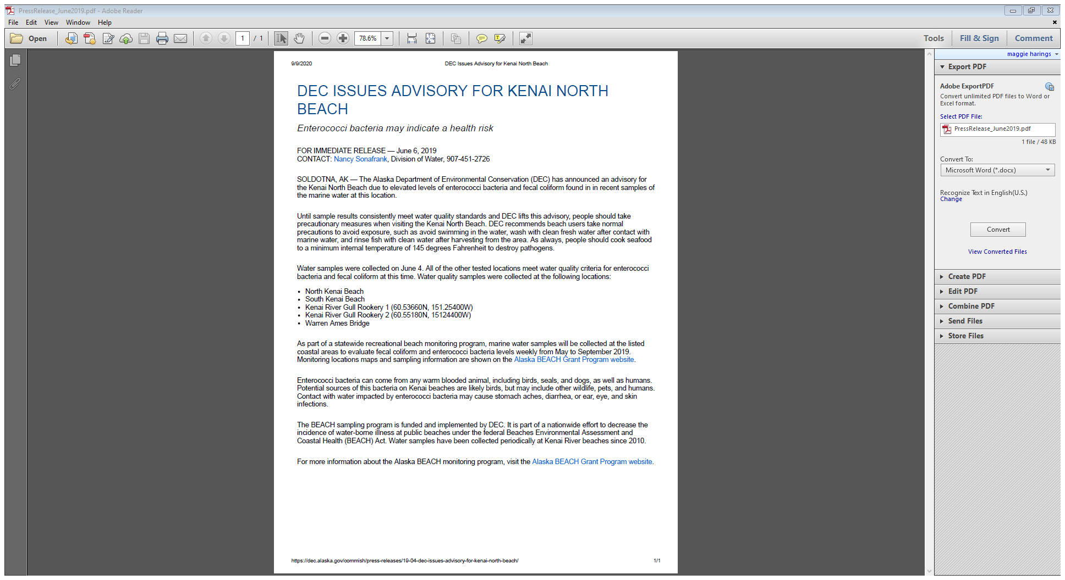

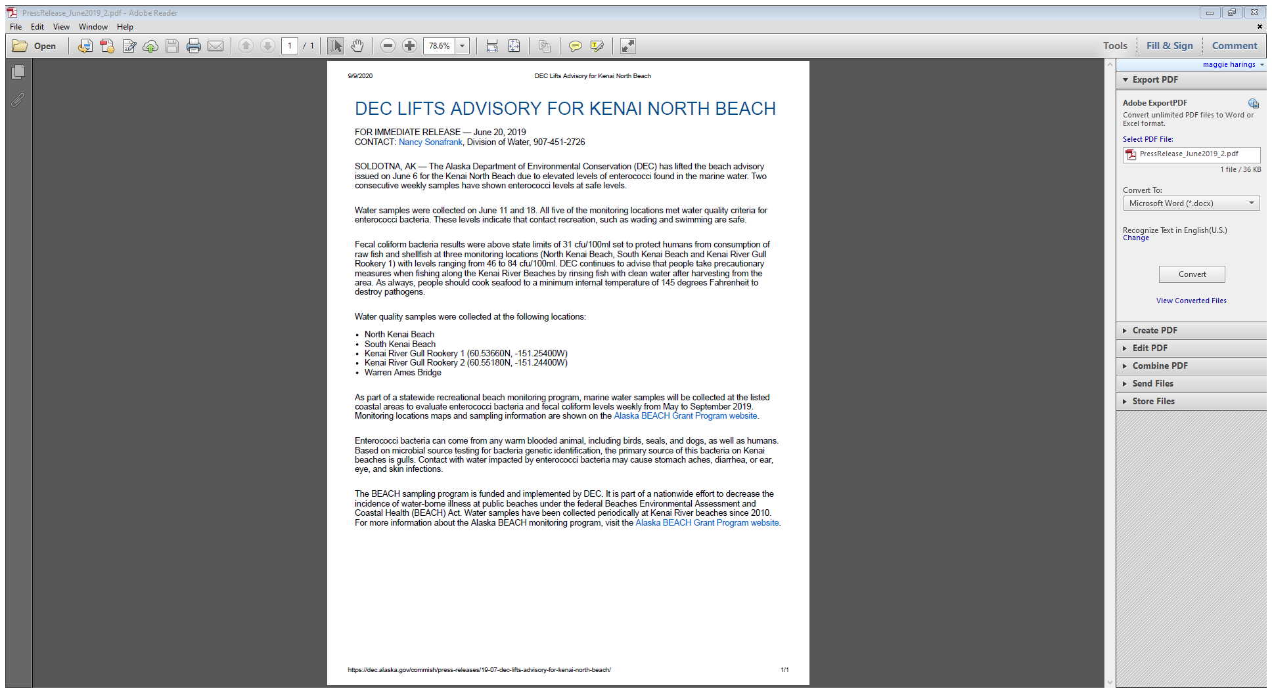

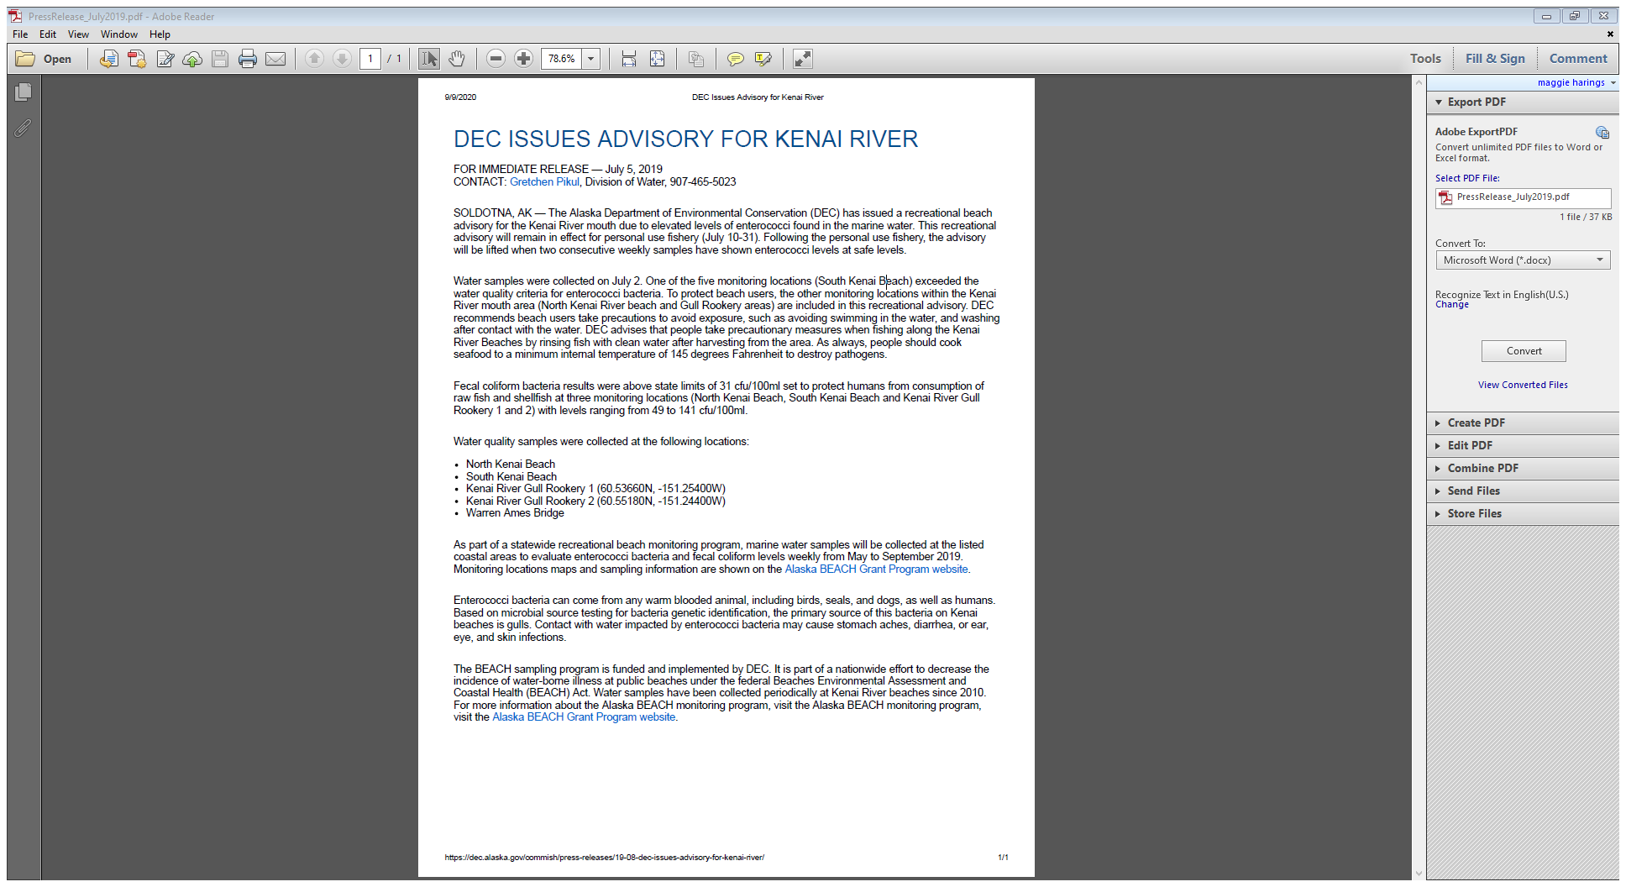

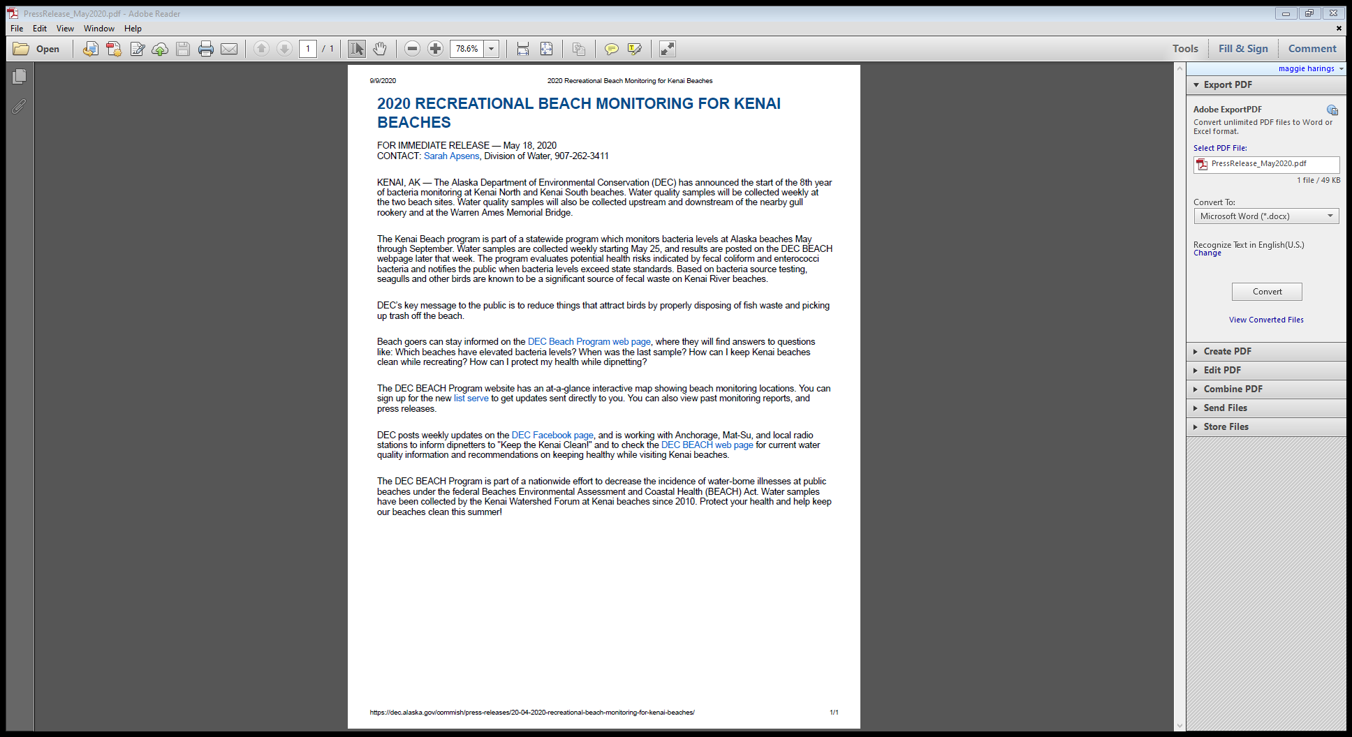

## **Appendix D: Site Photographs**

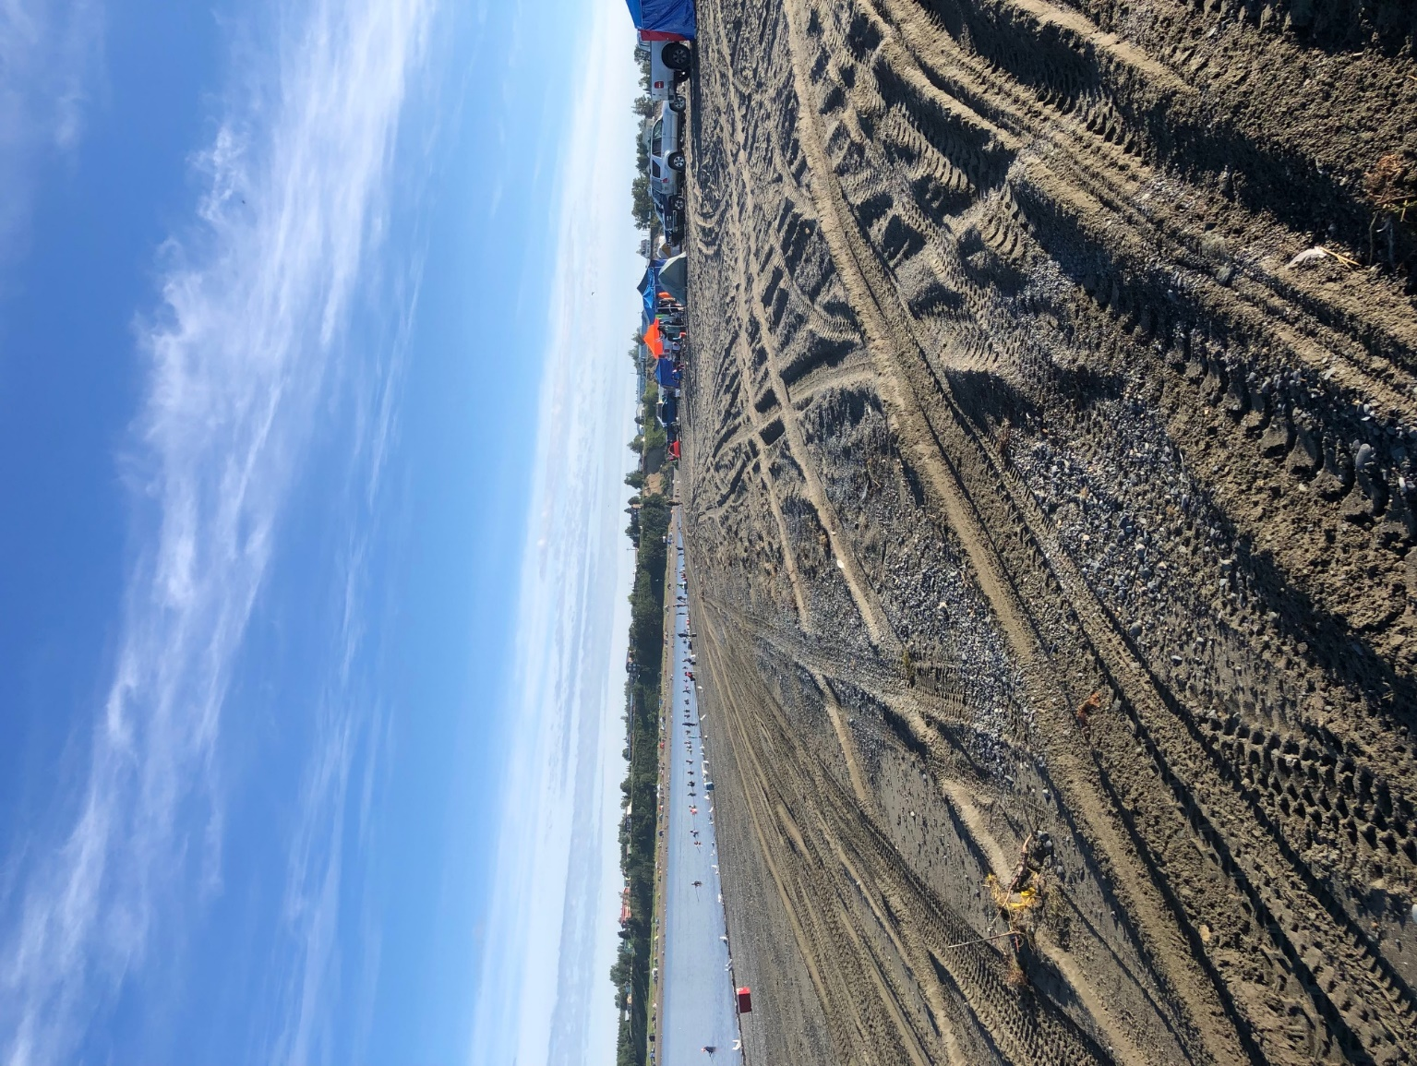

South Kenai Beach 3 sampling location looking toward the Kenai River outlet. North Kenai Beach can be seen in the background. Photo taken on July 27, 2020 during the personal use dipnet fishery season.

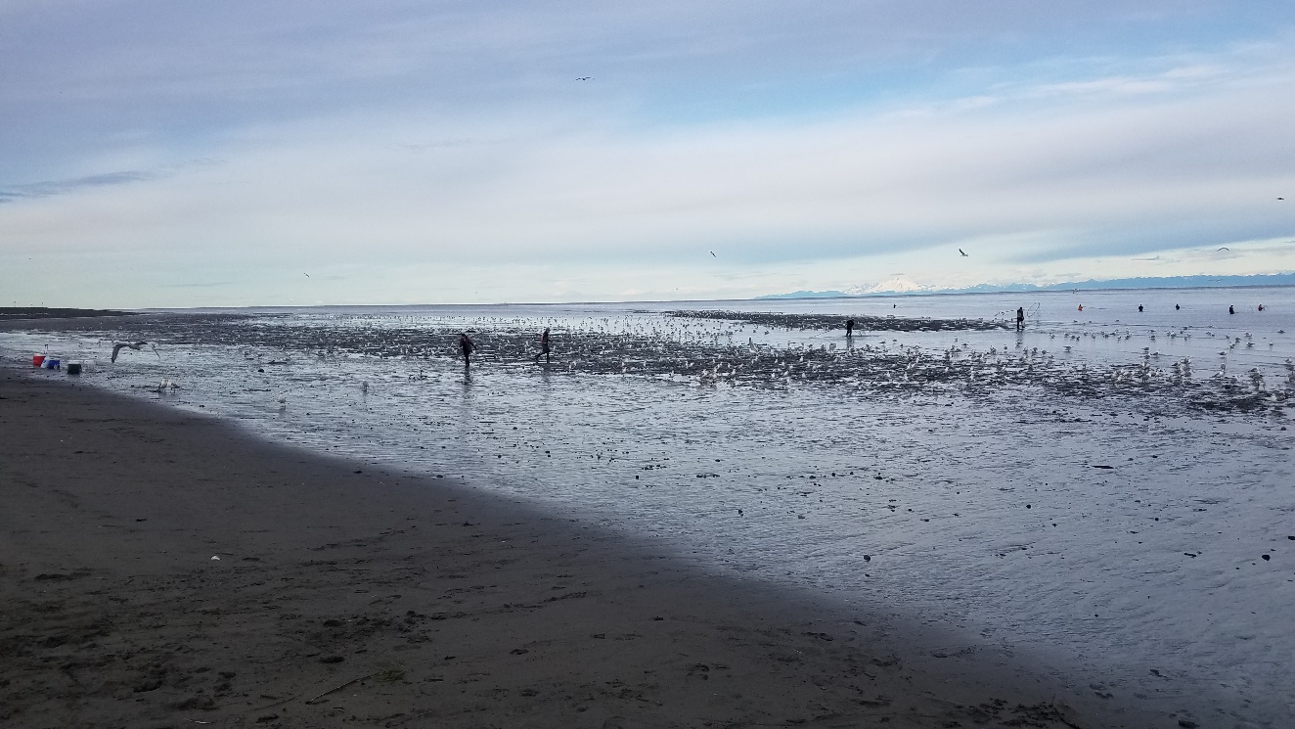

South Kenai Beach 3 sampling location depicting the highest gull count of the sampling season. Photo taken on July 20, 2020 during the personal use dipnet fishery season.

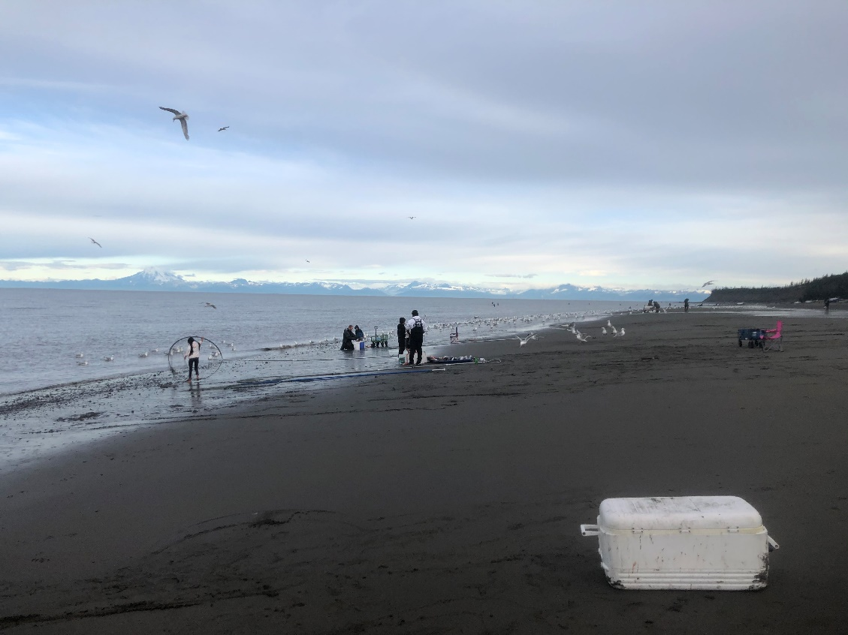

North Kenai Beach 4 sampling location. Photo taken on July 20, 2020 during the personal use dipnet fishery season.

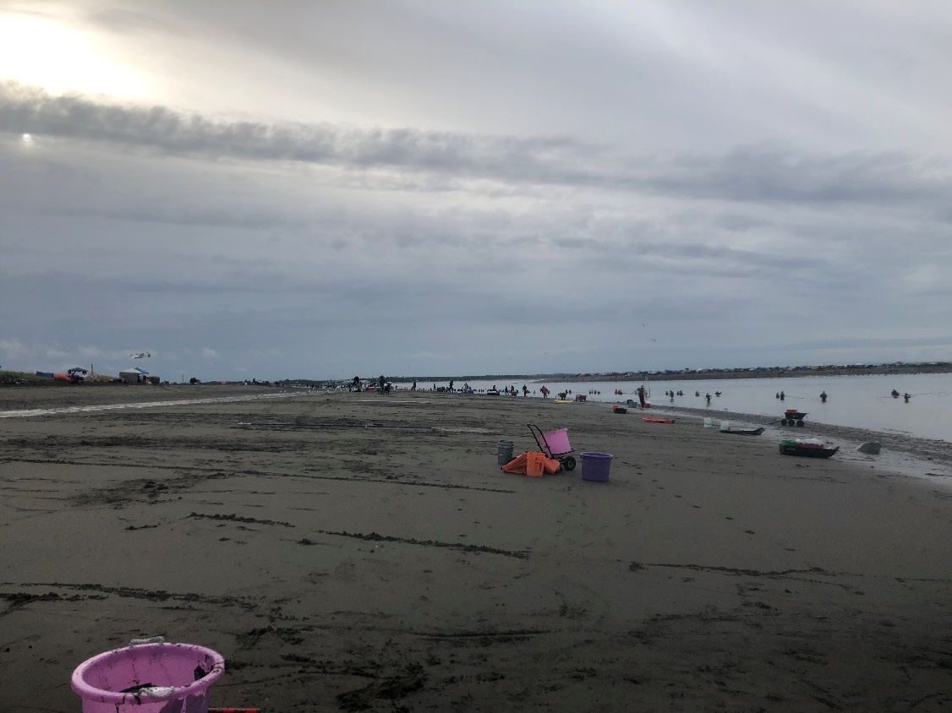

North Kenai Beach 4 sampling location looking away from the Kenai River outlet. Photo taken on July 23, 2019 during the personal use dipnet fishery season.

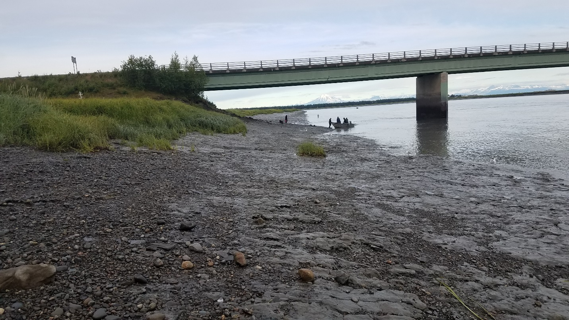

Warren Ames Memorial Bridge 1 sampling location looking downstream on the Kenai River. Photo taken on July 20, 2020 during the personal use dipnet fishery season.

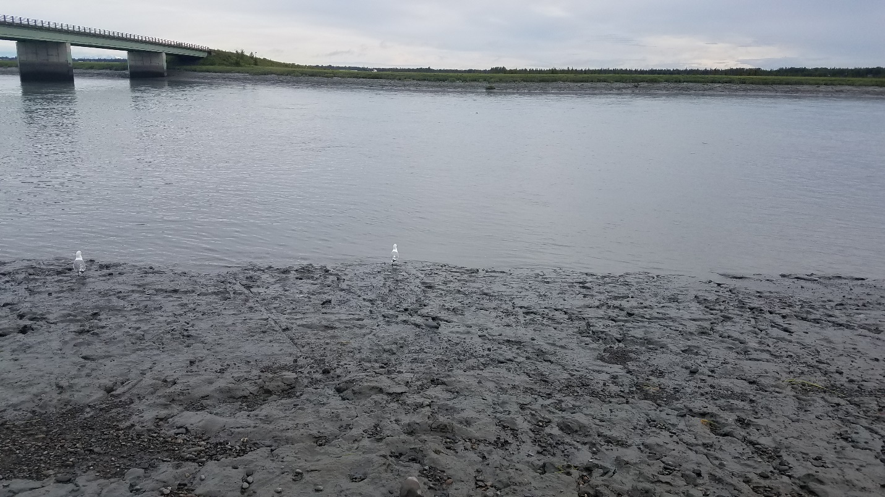

Warren Ames Memorial Bridge 1 sampling location on the Kenai River. Photo taken on July 20, 2020 during the personal use dipnet fishery season.

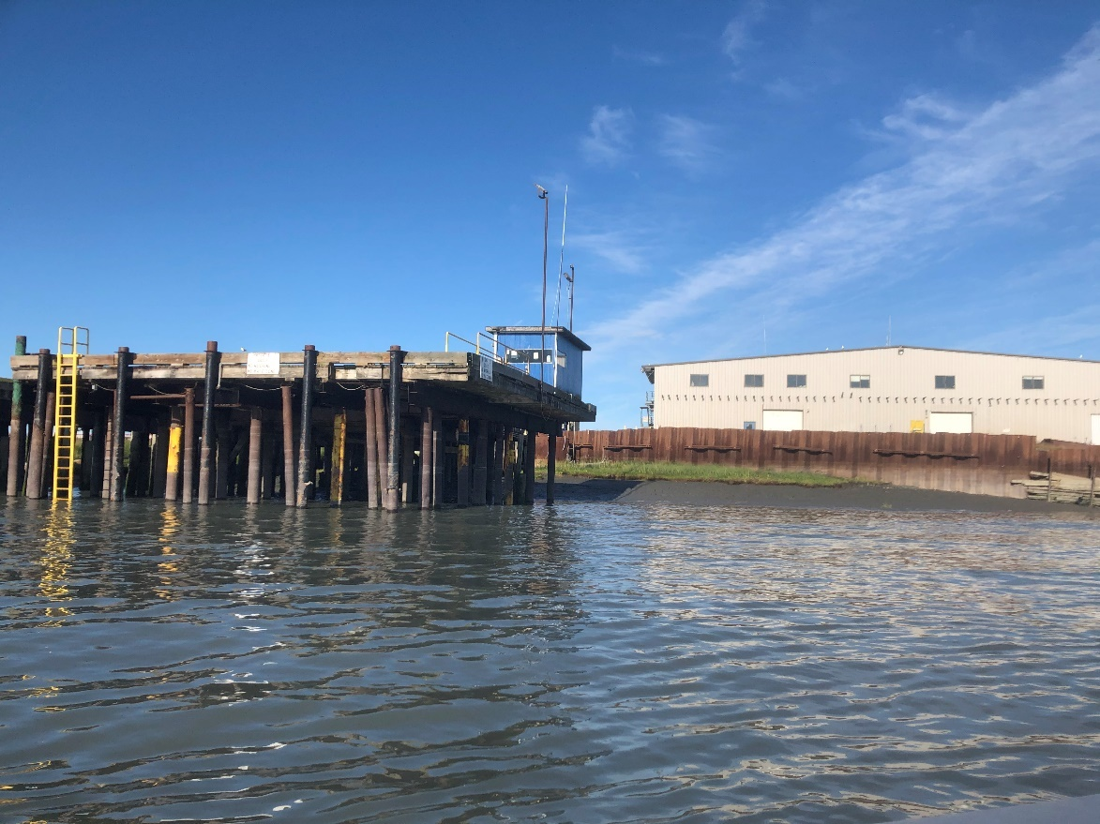

Kenai Gull Rookery 1 sampling location. The fish processing plant can be seen in the background. Photo taken on July 27, 2020 during the personal use dipnet fishery season.

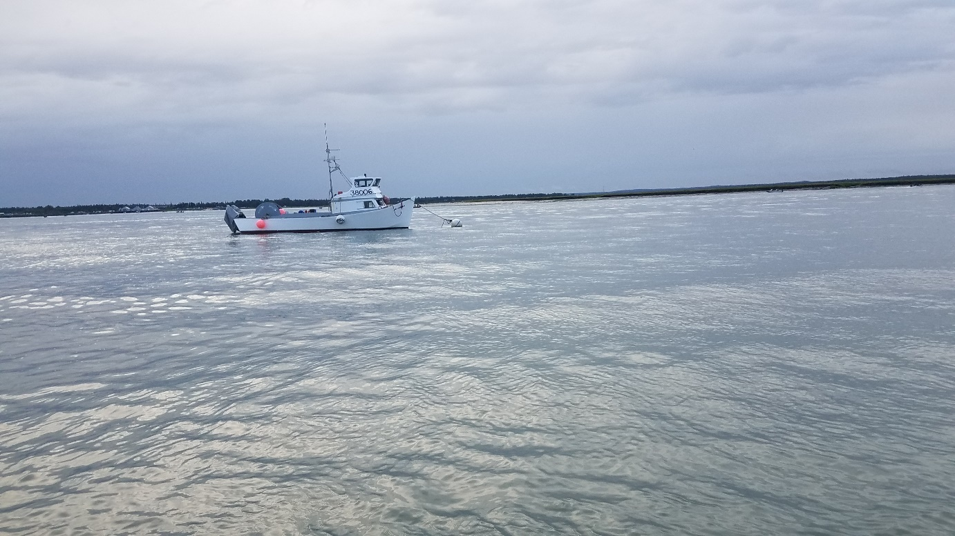

Kenai Gull Rookery 1 sampling location looking across the Kenai River. Dipnetting boats can be seen along the far shore behind the mooring boat. Photo taken on July 20, 2020 during the personal use dipnet fishery season.

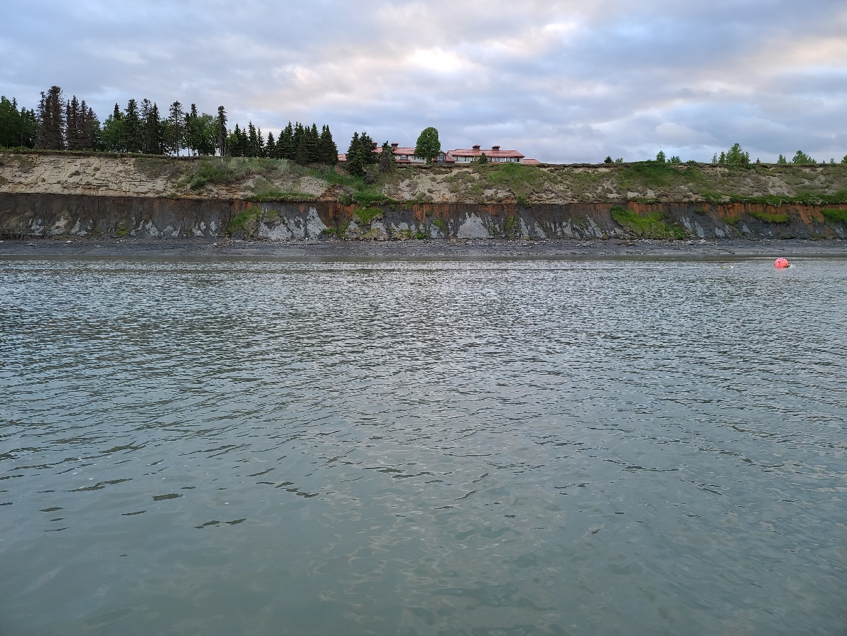

Kenai Gull Rookery 2 sampling location looking at river-right bank. Photo taken on June 18, 2020.

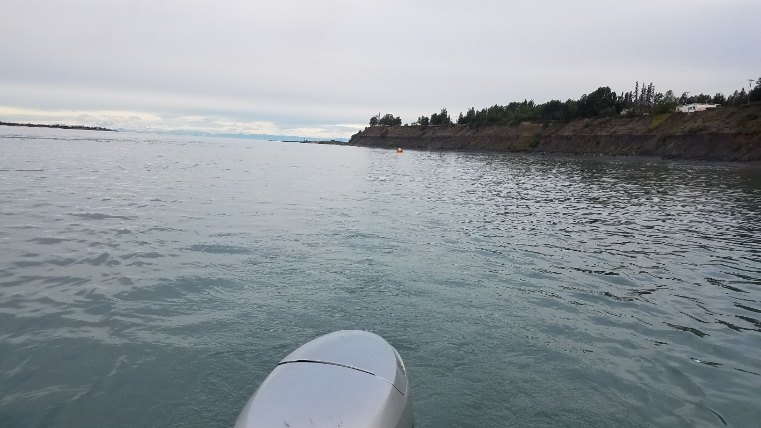

Kenai Gull Rookery 2 sampling location looking downstream toward Kenai River outlet and Cook Inlet. Photo taken on July 20, 2020 during the personal use dipnet fishery season.